

Recreate a Classic Arcade Game

1602756



RIAZ PHILIPPE

SUPERVISOR: SERaFEIM PERDIKIS

SECOND ASSESSOR: JIALIE SHEN

01: TITLE menu

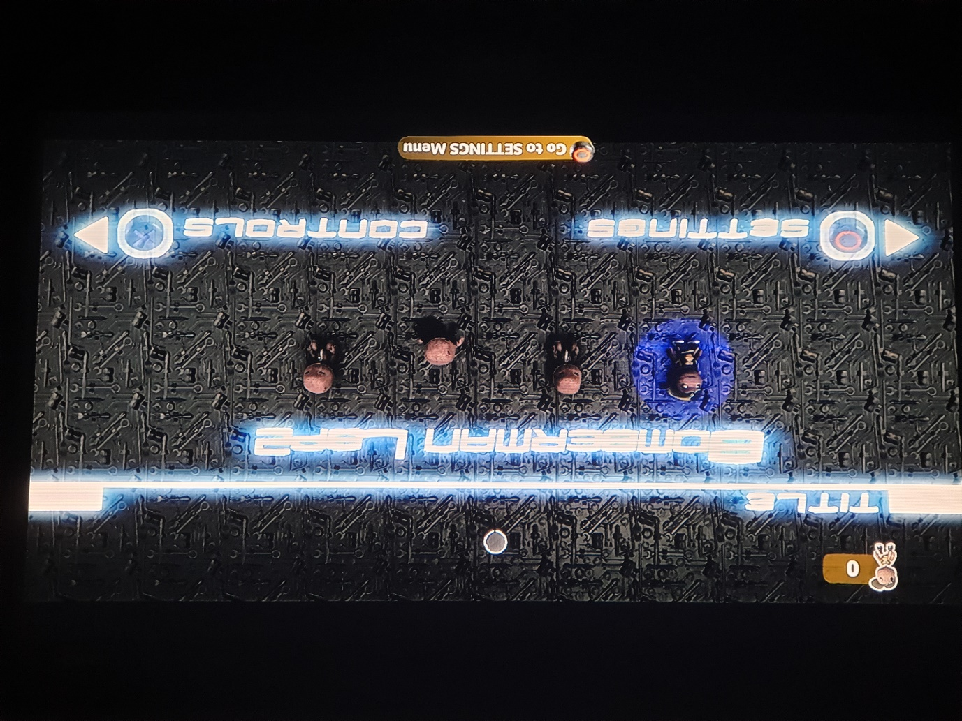

This is the first thing that players can see upon entering the level. In LittleBigPlanet 2 (LBP2), players have the ability to customise their avatar. Any active players who spawn into the game will replace the default “naked” avatar with their own custom one. Their avatar will also leave the default sleep state and enter a happy state to provide a visual indicator for successfully entering the game. Lastly, their avatar will be backlit by a glowing circle whose colour corresponds to their player colour during gameplay. The player is presented with two options: to go to the SETTINGS menu with the Circle button or to go to the CONTROLS menu with the Cross button. Note that the menu can only be controlled by the first player who spawns in which is normally (as their profile data generally loads the fastest on their own connection) the game host.

02: CONTROLS menu

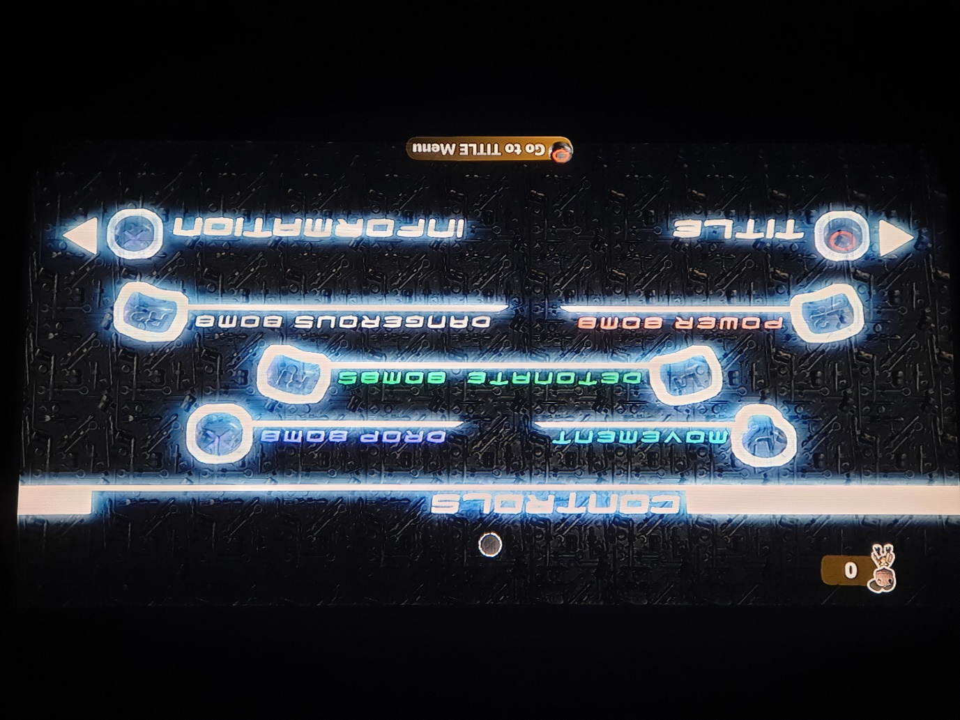

A very basic menu that provides a visual interface for the game’s button mapping. As the player progresses through these menus, the positioning of the menu title will shift somewhat. The Circle button will always shift the menu to the left (back to the TITLE menu), and the Cross button will always shift the menu to the right (to the INFORMATION menu). For instances where the menu title shift would move it off-screen, the title wraps to the opposite edge of the screen.

03: INSTRUCTIONS menu

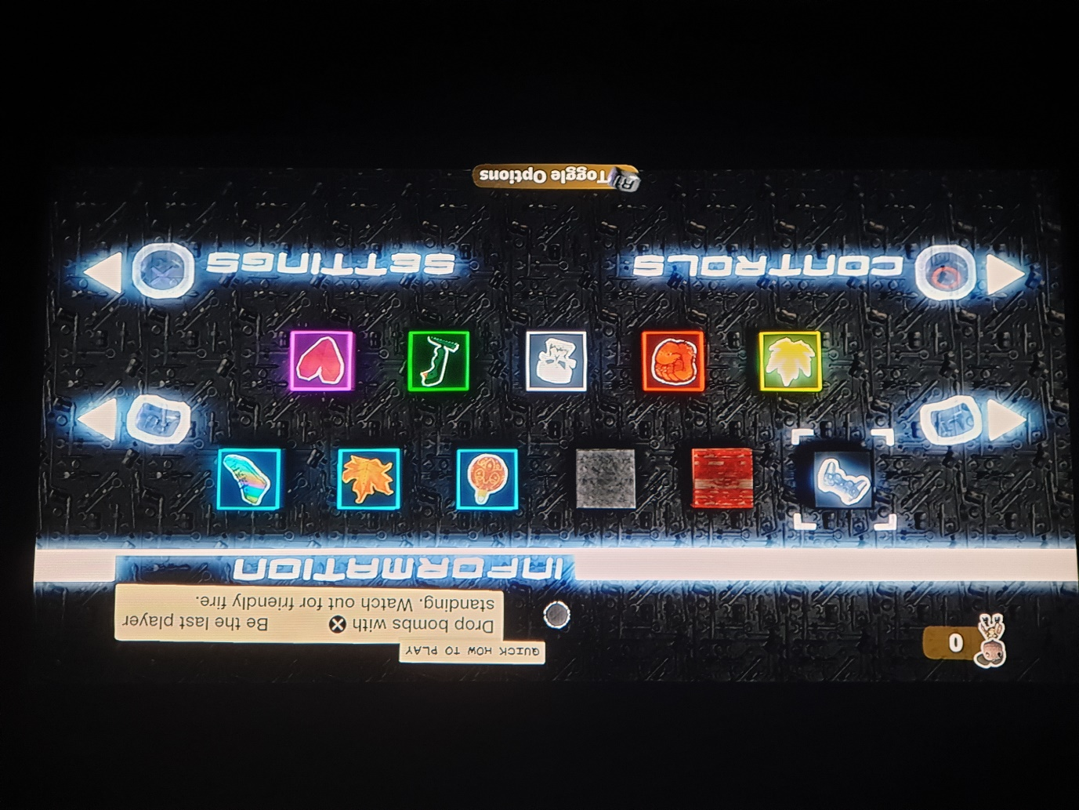

This menu holds the bulk of the information to inform the player of the functionality of the various objects encountered during gameplay. The player can use the L1 and R1 buttons to toggle left and right between the objects presented. During public beta testing, I found that with detailed description, players failed to properly absorb the given information which left them helpless during gameplay. It is because of this that all objects now only display very brief explanations at no more than 2 lines of text. In order from left to right, the displayed objects the player can browse through are: Quick How to Play (for newcomers, not actually found in-game), Soft Block, Hard Block, Bomb(-UP), Fire(-UP), Skate(-UP), Full Fire, Power Bomb, Dangerous Bomb, Remote Bomb, and Heart.

04: SETTINGS menu

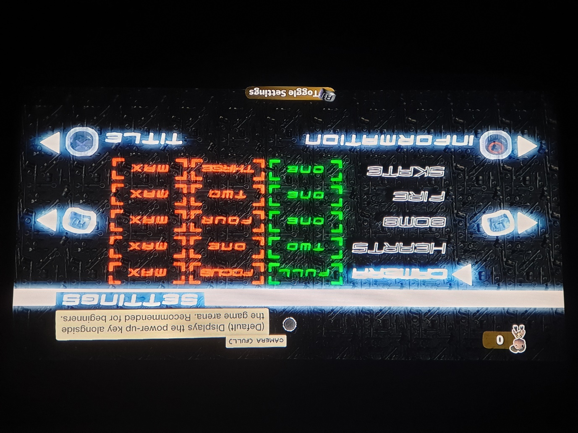

This menu holds a variety of customisation options to encourage replayability. As with the INFORMATION menu, the player can use the L1 and R1 buttons to toggle left and right between the options of the settings. The player can also use the Left Stick Up and Down to toggle up and down between the different settings themselves. This button map for this functionality is not displayed as it is a natural habit for those playing the game.

The settings themselves are self-explanatory aside from CAMERA. The CAMERA (FOCUS) setting removes the power-up key to reduce potential lag, and the CAMERA (MAX) completely removes Soft Blocks for the optimal running performance. I chose to favour displaying MAX over the actual values as the actual number becomes irrelevant, and I feel it makes for a nice consistent format for the rightmost column of the settings. Note that the leftmost column of the settings represents the default values.

05: PLAY

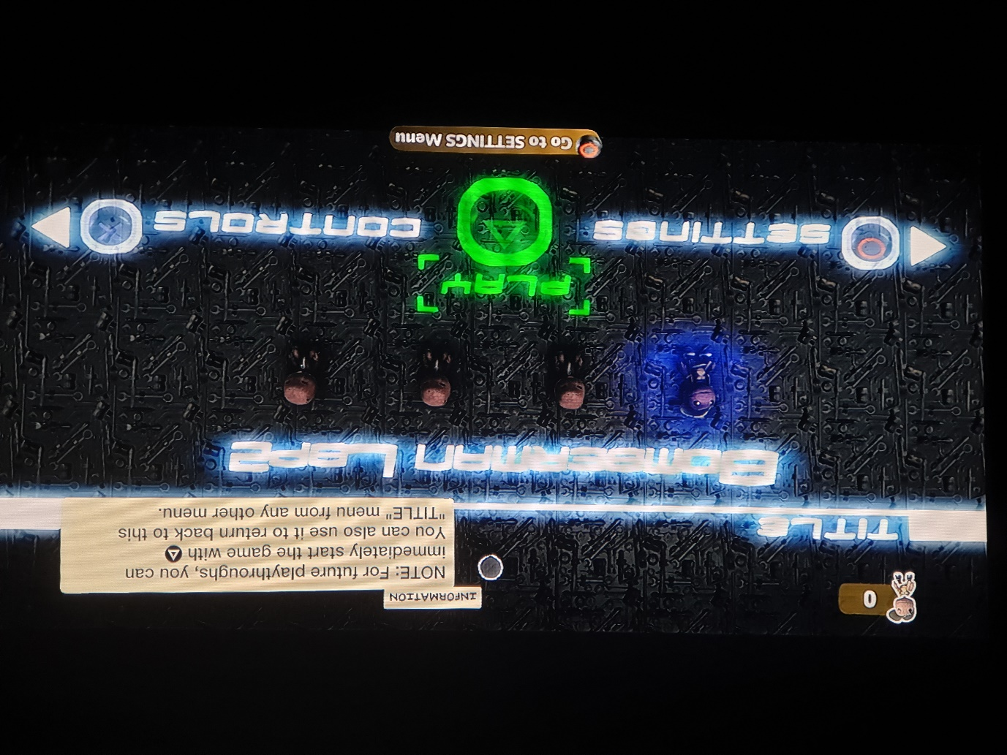

After the player has successfully visited all menus, a new PLAY option appears on the TITLE menu which allows the player to start the game. Note the INFORMATION text at the top-right portion of the screen. This informs the player of what is essentially a quick-start feature should they revisit the level.

I wanted to design the menu in a way which allowed for the game to be started as quick as possible for veterans and testing purposes, yet it also had to encourage newcomers to explore the menu to learn of the features the menu offered. During beta testing, the menu was initially designed so that the PLAY, INSTRUCTIONS, CONTROLS, and SETTINGS options were visible and available to select from the get-go. This resulted in naïve newcomers jumping straight into the gameplay, with no respect for the information within the menus. Ultimately, they would rob themselves of the experience and ruin their first (the most important) impressions of the game. The menu of the final build is admittedly less user-friendly, but I do feel that the compromise was a necessary sacrifice and player satisfaction has since seen a positive increase.

06: Initial Game State

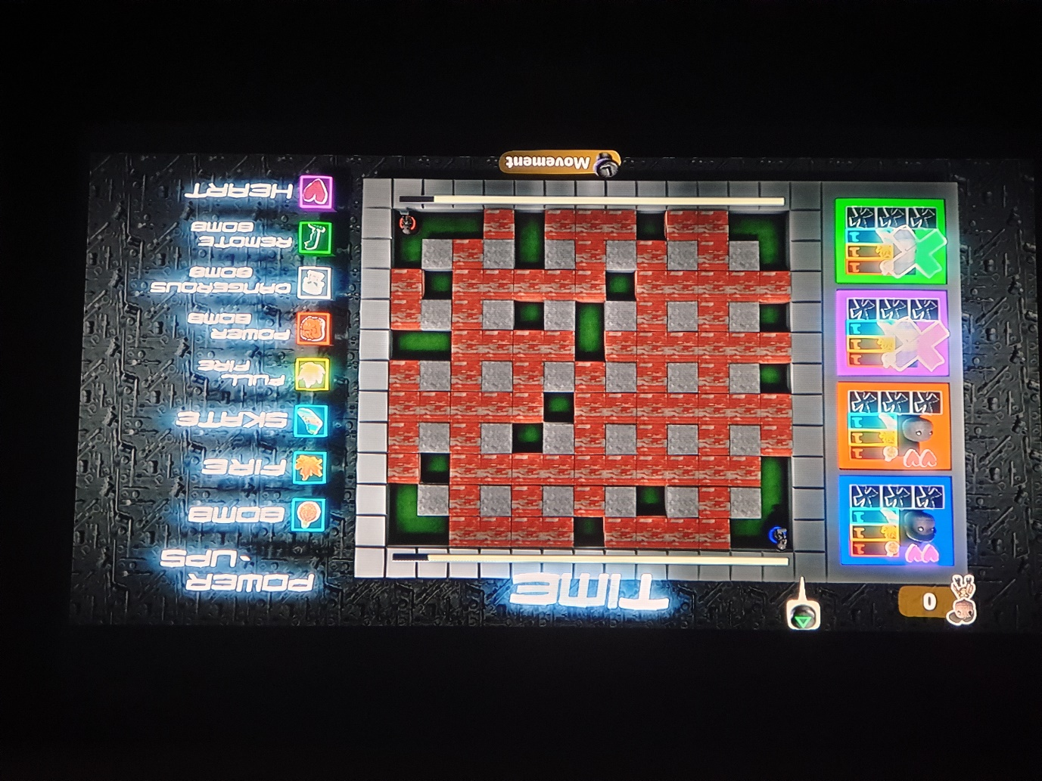

This is the initial game state of the game arena. To the left is the player HUD and to the right is the Power-UP Key which both serve to aid the player during gameplay. The Triangle button prompt is only visible during single player and it informs the player that the level is designed as a multiplayer only level. The level has no AI so the single player version acts as a sort of free roam/practice mode to allow for the player to explore and experiment with the game arena at their own pace. In single player mode, the player simply needs to destroy the red motionless opponent to win. This information is also present within the level description which the player sees before loading and entering the level itself.

07: Gameplay

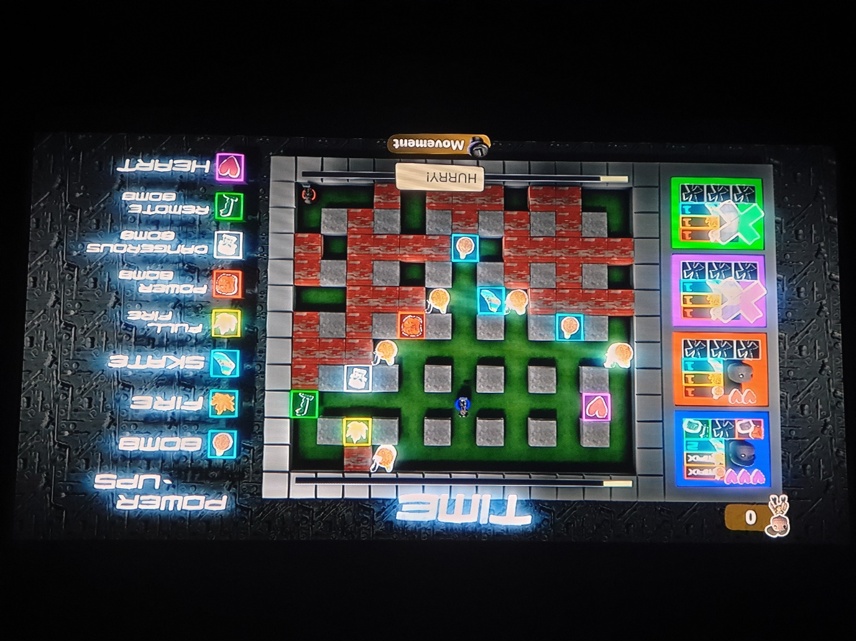

The player has two minutes to complete the objective. The player drops bombs to remove Soft Blocks so that they can reach and destroy their opponent before time runs out. As they remove Soft Blocks, they will discover power-ups which will strengthen their capabilities. The HUD informs the player of their current status. Note that when a player’s bomb, fire, or skate reaches the maximum capacity, the HUD value will alternate between the real value (e.g. Bomb 8) and “MAX.”

When the timer reaches 40 seconds, a text box “HURRY!” appears to inform the player that the game will soon be ending. Unlike Bomberman itself, pressure blocks do not start falling to lessen the size of the arena due to memory issues (more on this later). To compensate for this, the player is allowed to use their special bombs (the Power, Dangerous, and Remote Bombs) independently of their own bomb stock and these special bombs can also be used together.

08: Photo Time

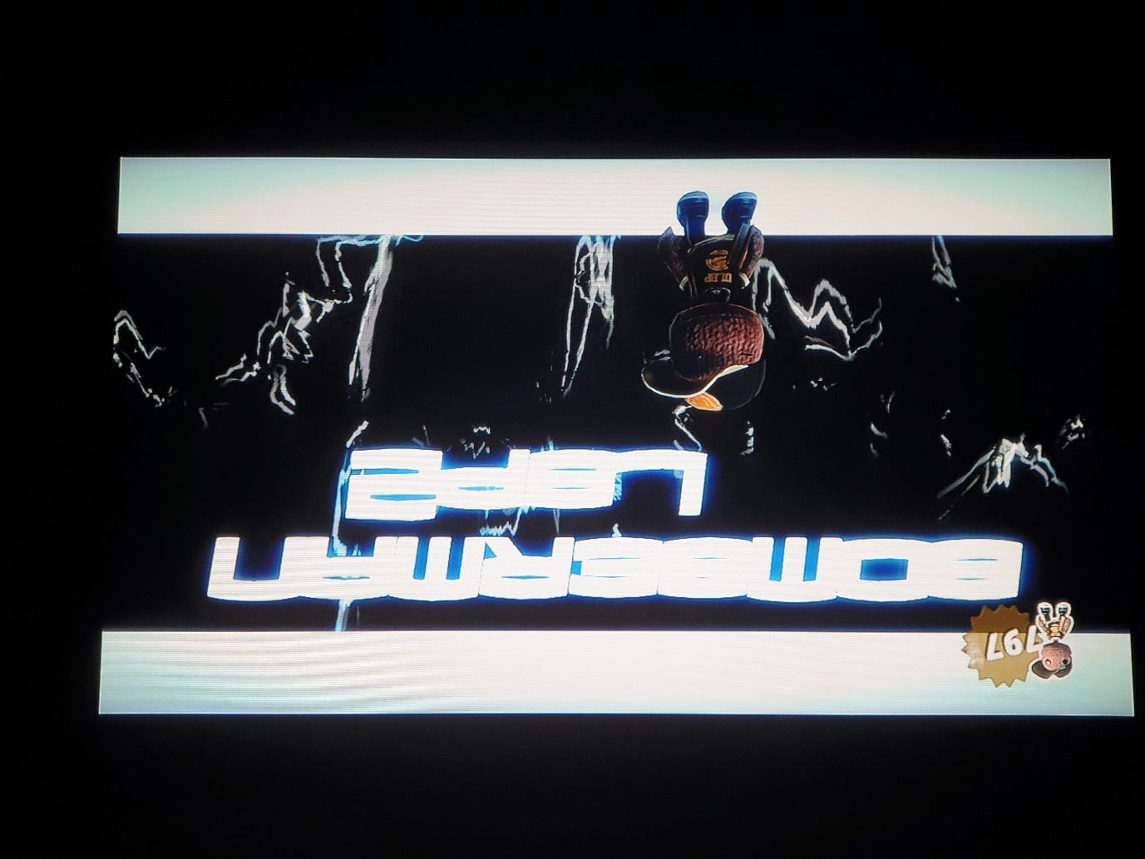

After the game ends by means of a draw, win/loss, or time out, the players are transported to this screen where they smile (and pose or show other emotions) for a photo. This section is completely irrelevant to the gameplay and is made more for the LBP2 community itself. LBP2 allows for players to upload photos to their profiles for others to see. In the case of level photos, it acts as a form of sharing and is essentially free level promotion. As the uploaded photos don’t provide information for where the picture was taken, the level title is provided for a reference.

09: Thanks for playing

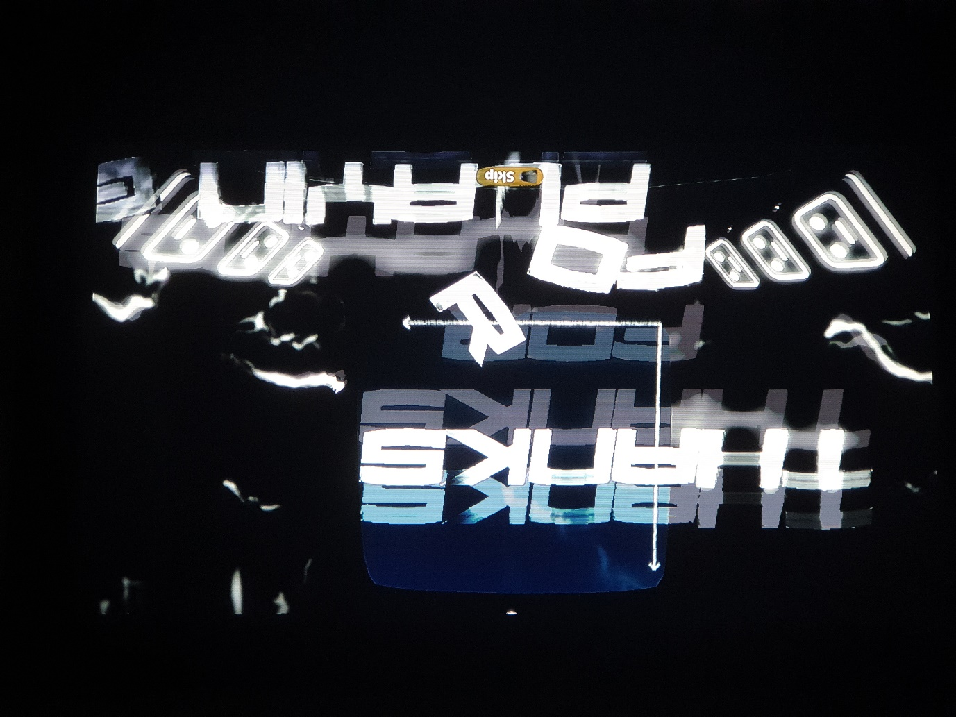

The final screen of the level. A “THANKS FOR PLAYING” text is seen (the transition is quick and it’s hard to properly capture), before collapsing, whereby the scores are weighed and the game ends. Due to memory issues, the game only supports a single round and players will have to replay the level if they wish to engage in additional rounds. There’s not much more for me to add concerning this section. Even if they didn’t like it, I am genuinely grateful for every player who took the time to give this level a proper chance and I felt the least I could do was say thank you.

10: Logic example

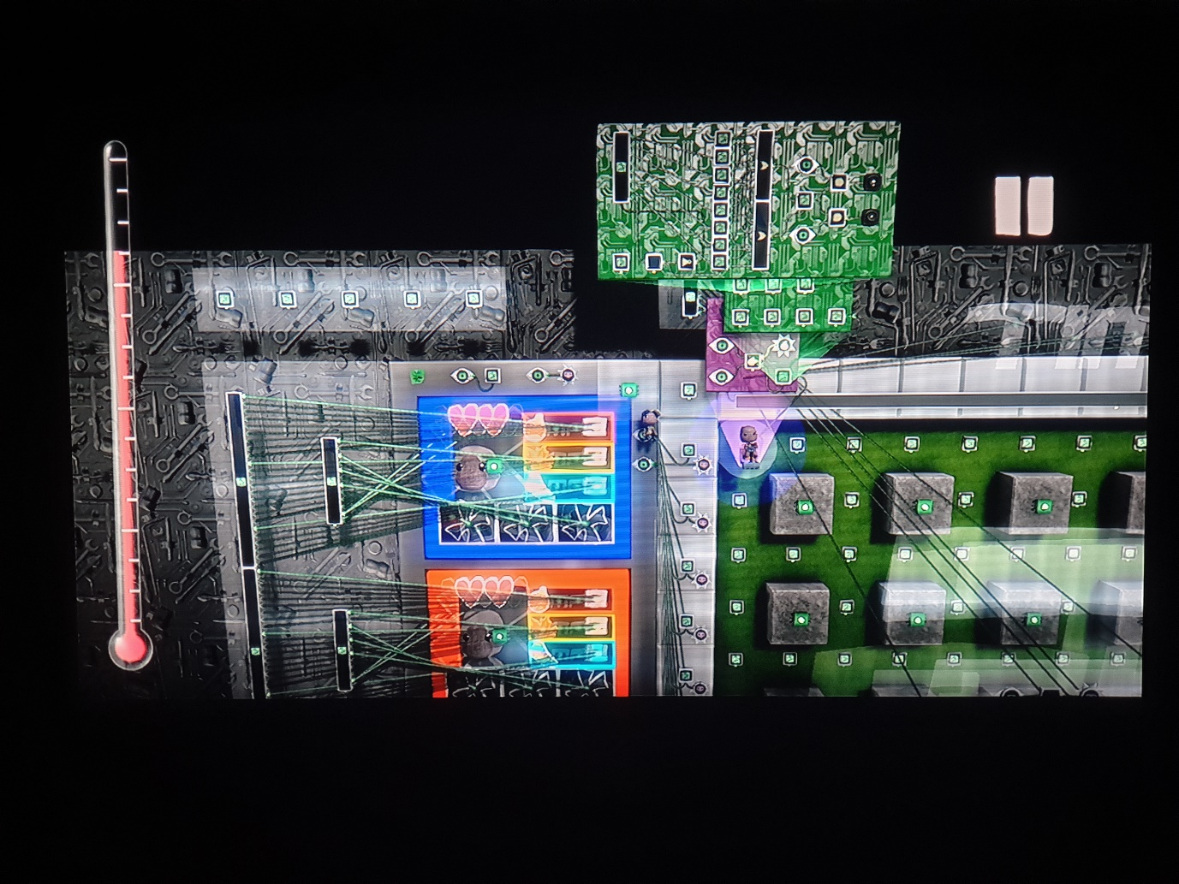

This is an example of some of the complex logic that was used to make everything work. It’s far too much to explain specifically how everything works, but just know that I had to look up a lot of tutorials and use what I had learned about programming and logic from the university to make this all work. Aside from the tools provided by the game engine itself, all the work done is my own.

To the left, you’ll notice a thermometer. This basically represents memory and it was my nemesis throughout development. A lot of concepts had to either be scrapped or simplified due to this and it really taught me the importance of respecting memory management. It taught me to compress my ideas, to keep things simple, to focus solely on getting the fundamentals of the game to work before expanding to make everything look visually appealing. There is nothing more heart-breaking in game development than to work so long and hard on something for it to go unused for one reason or another. This was perhaps, above trying to work my way amongst the numerous logic challenges, the most important lesson I took from pursuing this project.

Even though the thermometer still has space, when it crosses past the 75% threshold, crashing issues occur as player profiles also take up space and this causes it to strain to unstable levels. For a level that is supposed to encourage replayability, this was unacceptable. After a tiring amount of revisions, the crashing is now extremely minimal, and the level can be comfortably replayed without fear for a crash abruptly ruining the experience.